**CSCI 5708 – Mobile Computing**

|  |  |
| --- | --- |
| **Group Number** | MACS Group 7 |

|  |  |
| --- | --- |
| **Deliverable** | Project Proposal |

*Group Members*

|  |  |  |
| --- | --- | --- |
| **Name** | **Banner ID** | **e-mail** |
| Arshdeep Singh | B00890183 | singh.arsh@dal.ca |
| Bansari Hitesh Shah | B00910696 | bn272375@dal.ca |
| Bhavesh Lalwani | B00885318 | bl@dal.ca |
| Karan Singh Rathore |  |  |
| Parul Raich | B00903203 | pr678267@dal.ca |
| Sagarkumar Pankajbhai Vaghasia |  |  |

**Project Proposal**

**Table of Contents**

1. Abstract 3

2. Introduction 3

3. Background 4

4. Users 5

5. Purpose, Benefits, and Usage 5

6. Functionality 5

Architecture 7

7. Tools & Gantt Chart 7

8. Other (Remove if not required) 8

References 8

# Abstract

Our application helps connect start-ups and investors around the world. It provides a platform that helps start-ups initiate funding rounds that is accessible by people or investors who are looking to invest their financial capital. It adds a twist by providing a swipe interface to the users. The start-ups see a deck of cards showing potential investors. They can swipe left, for showing their interest or right based, if they are not interested on the investor profile and vice-versa. If both investors and start-ups are interested in each other, there will be match and they can initiate a conversation. Start-ups can close the funding round once finished.

# Introduction

With the application, we aim to provide a platform to start-ups and investors to engage with each other in a way not done before. When both of you, start-up and the investor, swipe right, you match. The investor shows interest in the product after hearing about it from you, the start-up and wish to invest. They give you the funding you agreed to. You close off the funding and it's a win-win on both sides.

The application UI/UX is inspired by the popular swiping feature on dating apps like Bumble [1]. Users are presented with a deck of cards representing profiles of either investors or start-ups based on the type of user. The deck of cards represents the profile information. The start-ups can put in their pitch in their profile, add a few pictures of the product or the business, market details like net worth and valuation. Investors can also write bios about themselves and their work history. Additionally, they can mention the money they can invest and the type of start-ups they might prefer.

Our target users are investors and start-ups globally. An investor can be anyone who has financial capital to invest and is looking for unique ideas or start-ups to invest their money in. A start-up on the other hand could range from an individual business, family business, a small local business, who are looking for funding for their business.

Table 1 gives a brief overview of the intended features of the application.

Table 1 Features of the application

|  |  |  |
| --- | --- | --- |
| **No.** | **Feature** | **Description** |
| 1 | Profile Management | Edit/manage profile |
| 2 | Swiping | Swipe on investors/start-ups |
| **3** | Conversations | Chat with matches |
| 4 | Match management | Match/un-match |
| 5 | Sign In Via LinkedIn/Google | Register or login via Google/LinkedIn |
| 6 | Agreement for fundings | A consensus between start-up and investor regarding funding terms |
| 7 | Activity Status | Last seen of the user |
| 8 | Geo-Filter | Filtering users by city/country |
| 9 | Profile-Verification | Verification of user via LinkedIn |
| 10 | Turn off the hunt | Disabling further visibility on complete funding |
| 11 | Meeting Schedule | Integration with calendar to plan meets |
| 12 | Subscription | Premium/paid subscription model |
| 13 | Wallet | Wallet for funds and payment management |
| 14 | Advanced Filters | Granular geographic filters |
| 15 | Engagement Encouragement | Automatic un-match if conversation not initiated within a certain time |
| 16 | Video Pitch | Upload a short video pitch in profile to showcase product/business |

# Background

To get more context on the area of focus of this project and the targeted audiences for the project, we researched in some existing application on the similar ideologies as ours and modern trends which are prevalent in global market for both investors and start-ups.

**“Bumble Bizz”**

“Bumble Bizz” is a variant of popular dating application “bumble” focusing on building the professional networks between individuals and organizations. Based on the same basic functionalities of bumble but with a professional twist, the Bizz mode also has the popular “swiping left or swiping right” feature [1]. The “swipe deck” in this application usually has industry experts, potential recruiters and other influential professionals would want to connect with individuals. In addition to the “swiping” feature, bumble Bizz also has an advanced feature of using local location of the professional individuals and organizations for suggesting professional connections in their local area [1].

“Bumble Bizz” like its predecessor “bumble” focus on the same women-centric approach and the Bizz app also has the “woman has to make first move” feature [2]. According to a study on the Bumble Bizz, the author Jeremy Bender [2022] of the article feel that this application could particularly prove be a great hit for small business owners trying to connect with more entrepreneurs and individuals of the same field of expertise and required skillset [1].

**“Shapr”**

Another application with similar ideology is “Shapr”. Shapr focuses on providing a tailored list for based on industry and skillset of user’s preference. Like Tinder, Shapr also has the feature of “swipe left or swipe right”. “Swipe right” is to connect to the individuals or organizations profile that interest the user and “swipe left” is to pass on any profile that might not interest the user. The list of tailored suggestions by “Shapr” is based primarily on “skillset of a profile” and “goals of a profile” that have been entered at the time of creation. Furthermore, “Shapr” also has a feature where in the user can set their availability and preference of connecting with others, for instance “after work”, “video call”, “weekends” and many more, which given an idea to organizations and people looking to connect with user’s availability beforehand [3].  
 This application also gives an option to look for opportunities near the user’s local location proximity or major cities near them [4].

While researching on some rampant and upcoming trends that attract the recruiters to job seekers the most, we came across an interesting article on “Video Resume Creation Platform”. Intro30, a technology-based start-up from California, USA, is offering a platform to individuals keen on creating “video resume”. Their tool would allow the users to create 30 sec introductory videos that could go along with the resumes. Intro30 is a complete job recruitment platform, wherein after the user signs up in the application and makes a profile, they can browse through the various job posting provided by the application and apply for the same through the application. While applying they can also upload the curriculum vitae (CV) and the resume video. The founders of the start-up believe that these “video resumes” could have great impact on the hiring managers. Moreover, they feel that the viewing “video resume” would not only save time of recruiters but also give them an idea about the applicant’s “soft skills” [5].

Although our application is based on a similar ideology as above applications “bumble Bizz” and “Shapr” ,we are targeting a more specific audience for our application consisting of start-ups and investors. Taking motivation from the video resume, we are also keen to add in the concept of video pitch in addition to the text pitch as an advanced feature at the later stage.

# Users

There will be two kinds of target users for our proposed application as mentioned below:

1. **Start-ups**

Companies in the initial stages are on a low budget and do not have an adequate amount of funding. They always look to connect with investors who are like-minded and have the expertise that can help them grow the business. Our application will allow such start-ups to connect to such investors and raise funding, strengthening their business. It gives these start-ups the unique opportunity to attract investors across the globe. The start-ups do not need to wait for investment events, this app will facilitate them to attract funds whenever they wish to throughout the year. Even start-ups that sometimes do not get qualified, or do not get the chance to display their business in investment events get the opportunity. Contacting multiple investors at once gives them a fair chance to negotiate the deals and get the best expertise on board in the form of investors.

1. **Investors**

Investors continuously look for start-ups that have the potential to scale, stay profitable and be in demand. Our app will give such investors a variety of start-ups looking for funding across the globe. It will allow investors to communicate with them and discuss how the funds are going to be used. Investors will get to browse through start-ups that are of interest to them. It will allow investors to have talks with multiple start-ups simultaneously and choose the best one later. It gives both parties ample amount of time to discuss the opportunities, set clear expectations, and see how they can grow together the business.

# Purpose, Benefits, and Usage

# Functionality

**6.1 Minimum Functionality**

**1. Profile Management**

Profile management gives users the tools they need to edit or create a profile. Creation will encompass signing-up for the application. Users provide some mandatory registration details and create a profile. Details including but not limited to pitch/bio, photos, location, funding required/funding available can be entered into the profile. Additionally, the user can view how their card looks on the deck and make any changes based on that.

**2. Swiping**

The swiping mechanism is the heart and soul of the application. Depending on the type of user, users are given a deck of cards that represents the profiles of either investors or start-ups. The profile information is presented on each one of the cards. The users swipe left to dislike a card, and swipe right to like a card. If both the users(investors and start-ups) swipe on each other, then it is considered a match. They will see each others profile card in the conversations screen, and either one of them can initiate a conversation.

1. **Conversations (Messaging/Chatting)**

When users get the match, they can see an option to start the chat with the matched person. Any one of the users can initiate the chat. They can use this feature to connect with their potential opportunists, they can introduce themselves and give a proposal. Users can see all the chats with their matched candidates in the conversation screen. Start-ups can use this feature to explain more about their idea or project, investor can use this to explain their investing plan and negotiate the terms.

**4. Match Management**

Match management includes un-matching a user, you no longer want to engage with. User here represents either an investor or a start-up. There could be any number of reasons, a user may want to un-match. Once a user is un-matched, the conversation will be removed from the chats, and they will no longer see the profile of the un-matched user on the swiping deck. This goes for the un-matched user as well.

**6.2 Expected Functionality**

**2. Activity status - How proactive a user is (usually responds in )**:  
Considering the focus of our application to be on professional interactions, Activity Status in our application would be related to the average time usually the user responds to the messages they receive. This feature could be used by both set of users of our application and needs to be specified during the profile creation step of user registration. Users could also change it from the settings later if the need arises.

**3. Filters (By Country / Cities)**

Users of our application will be able to make professional connections with the people residing in other countries as well cities by filtering their search criteria with country or cities. This feature will help the users to make connections very easily as per their preferred location.

**5. Turn off the hunt – (Disabling visibility in swipe cards for both set of users)**

Users of our application could also disable their visibility from the application, when they are no more looking for opportunities to connect. By disabling their visibility, they would no longer to be considered for the profile suggestions to other users.

**6.** **Meeting Scheduling**

Users could book the date and time from calendar of the profile they are interest to schedule a meeting with after both the parties have right swiped on each other and connected once from the application chat/contact information provided in the application. A day before the scheduled meeting in our records, the users would be provided notification of the upcoming meeting. While our application at this stage would not be able to provide a full-fledged video-interviewing or meeting platform, we would be recommending the some of the apps popular with most of the users of our application to the users looking to meet and they connect on those platforms. The data on the most popular application would be periodically taken from users using the surveys and questionnaires.

**7. Agreement for fundings**

Once there is a common consensus between the investor and the start-up and they are ready to make a deal. Our app will allow both parties to sign an agreement that will have the terms and conditions as per the offered deal like the amount and share in the company. Once the agreement is signed by both of them, the deal will be considered close at the end of our application.

**6.3 Bonus Functionality**

**1. Advanced Filters – More specific location filtering – (within x miles)**

Apart from providing standard functionality to filter by countries/cities, we will add additional functionality to search for start-ups and investors that are located within specific distance only. This will help the users to find and to make connections easily and as per their preferences.

**2. Automatic un-match if conversation not initiated within a certain time frame.**

If a connection is made and any sort of conversation is not initiated within 1 week then we will provide a functionality of automatically unmatching that connection from the network.

**3. Subscription**

Our app will have a paid subscription service for both investors as well as start-ups. The investors will get premium benefits such as reaching out to a certain number of start-ups and starting conversations with them without getting matched. On the other hand, start-ups would be able to reach out to a certain number of investors without getting matched with them. Both sets of users will get to feature in a different section of top investors and start-ups.

**4. Video Pitch**

Start-ups can upload a short video pitch displaying their business plans and products to attract investors. This will be in addition to the text pitch, giving an extra opportunity to attract investors. It will be an effective way for investors as well to know about start-ups.

# Architecture

# Tools & Gantt Chart

**7.1 Tools**

1. **Android Studio**

This tool will be used for application development where Kotlin will be used as programming language.

1. **Jira**

This tool will be used to follow Agile process in our project and collaboratively managing the team members to work on different features.

1. **Teams**

This tool will be used for communication with the group members and arranging online meet ups for the project discussion.

1. **Git**

This tool will be used for maintaining the source code. We can easily track changes in the source code, enabling multiple developers to work together on non-linear development.

**7.2 Gantt Chart**

Following chart gives an overview about the timeline of developing an application:

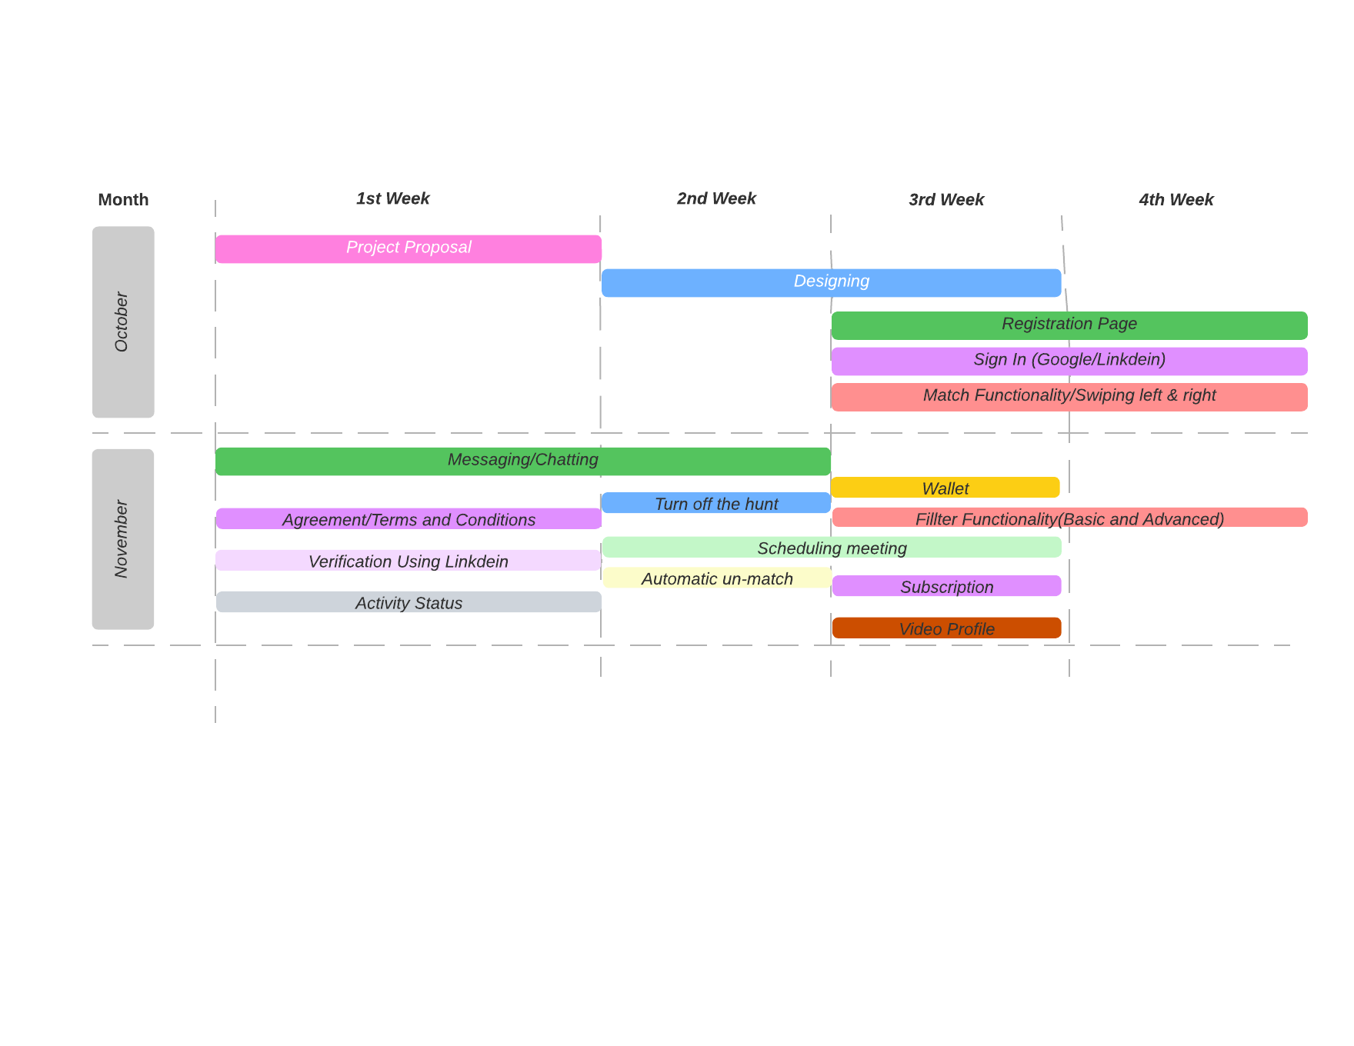

# Other (Remove if not required)

# References

[1] Bender, J., 2022. What Is Bumble Bizz?. *Business News Daily*. Retrieved from <https://www.businessnewsdaily.com/10532-the-buzz-on-bumble-bizz.html> .

[2] Colomby, J., 2022. Bumble Bizz Empowers Women to Make the First Move - Bay Street Bull. *Bay Street Bull*. Retrieved from <https://baystbull.com/bumble-bizz-empowers-women-to-make-the-first-move-towards-a-career/> .

[3] Seshadri, A., 2022. Shapr — App Review. *Medium*. <https://medium.com/@anuraagseshadri/shapr-app-review-42cc8f72b8fe> .

[4] SAIGAL, R., 2022. Shapr Makes Professional Networking as Easy as a Right Swipe. *MUO*. Retrieved from <https://www.makeuseof.com/tag/shapr-professional-networking/> .

[5] Video resume creation platform – job listing marketplace for applicants launched: Novato, california-based startup Intro30 has just released its innovative video resume creation platform, which helps job seekers make a strong impression on recruiters,2021. *NASDAQ OMX's News Release Distribution Channel* .Retrieved from <https://ezproxy.library.dal.ca/login?url=https://www.proquest.com/wire-feeds/video-resume-creation-platform-job-listing/docview/2520063813/se-2> .